**Chapter 1: The Historical Background of Cacao and its Trade**

**1.1 The Divine Function of Cacao**

The Theobroma cacao tree, also translated as the "food of the gods", has been an integral part of Mesoamerican culture for over 3,000 years. For the Maya and the Aztecs, cacao was much more than a delicous food—it was sacred food. It was a connector between the human and divine worlds. When drinking cacao as part of a religious ritual, drinks were offered to the gods. When rulers (caciques) died, they were buried with cacao beans as a ritual offering to the gods or as a form of currency in the afterlife. As evidenced by its consumption for thousands of years, cacao gained status as a form of wealth and was associated with elite status.

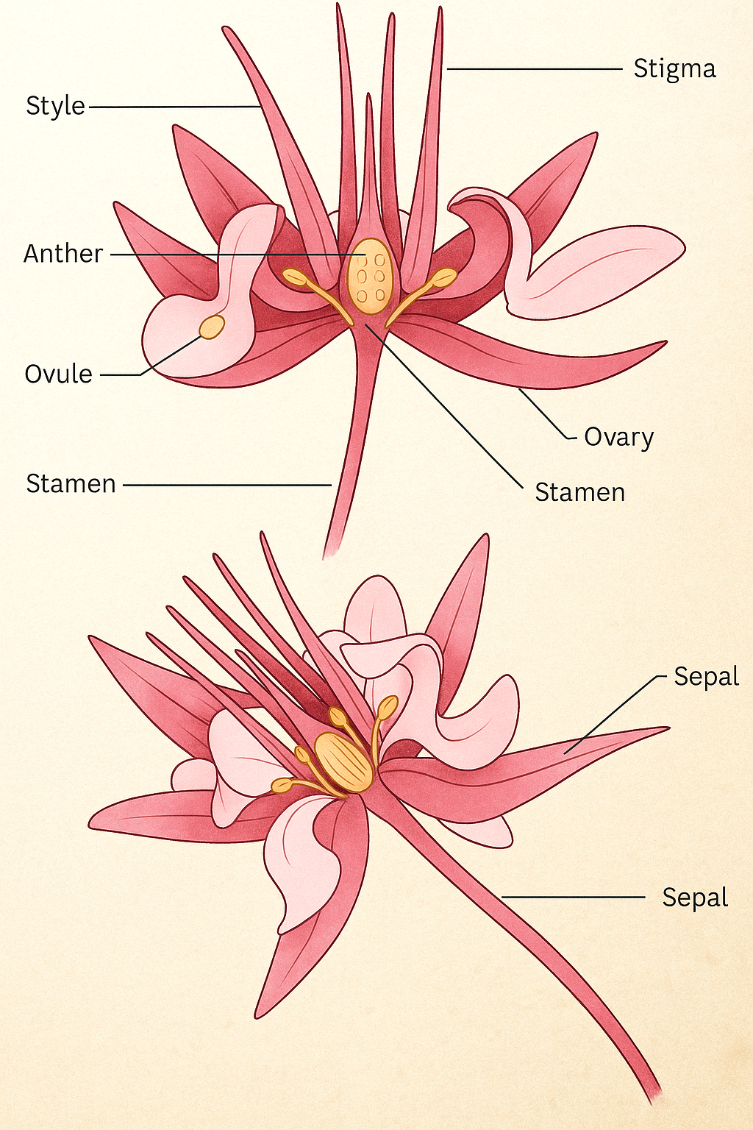

## In the Maya sacred text, Po-pol V uh, cacao is mentioned frequently with maize, and they are included in the Maya's creation stories, and are part of their cultural identity. Cacao was not just a crop; it was a gift from the gods and essential aspect of their society. The Aztecs elevated cacao's importance when they offered cacao-based drinks to their warriors in battle, because they believed cacao helped strengthen their minds and bodies and improved their endurance. Science begins to explain this; The obromine is a mild stimulant in cacao, and it is a rich source of flavonoid for energy and mood enhancement. Therefore, and for both physical as well as spiritual purposes, cacao was perceived as a rich resource that was mostly given value.

## Cacao was also a luxury beverage that was foamy and slightly bitter with spice, chili, or vanilla. Cacao beverages were a privilege of the elite, warriors, and priests, which guarantees staying the linked to power. Preparing such beverages was no small ordeal, as it required a certain level of skill and knowledge that was passed on, and that knowledge only enhanced cacao's cultural importance. All the effort to grow, harvest, and prepare cacao took time and labor, and increased its value, levels of sophistication, as it was seen as a sophisticated beverage of prestige.

## 1.2 Cacao as Currency and Medicine

## In ancient Mesoamerica, cacao beans were food and money. Historical records of the Aztec civilization demonstrate that the cacao beans had established values; for example, 100 beans were enough to purchase a turkey, while 10 beans would pay for other services such as hiring a laborer, paying for a simple meal, or for more personal matters. This was just one example of the various roles that cacao played in the economy. More than just an economic actor, cacao had important symbolic weight and was a medium of exchange that was connected by industry (use), time of year (reward), geography (presence around the region), and politics (the Spanish imported capable labor in chronic time of need).

## Cacao also had a captive audience for rituals which related to divination medicine. Healers of the time in Mesoamerica commonly used the crushed form, ground heroes, and then mixed with herbs forms cacao into remedies for a range of ailments - digestion issues, energy deficiencies, fevers or waning spirit. They noted that cacao could lift one's spirits and provided energy; and this supports contemporary science of the chemical form of cacao. Cacao contains theobromine keeps alert, and the flavonoids that improve heart health and maintain moods.

## The medicinal uses served as the foundation of the indigenous healer's more advanced knowledge of the human body, mind, and spirit, where direct links to cacao-related treatments could be planned out and tailored as per the needs of the patient - as practitioners pushing the limits of reality.

## Cacao's presence as a currency and medicine for economic and cultural practices and health but it took that to unprecedented levels.

## 1.3 Early Cultivation and Trade

Cacao enjoyed a prehistoric life in the humid lowland forests of modern-day Mexico, Guatemala, and Honduras, where the tropics provided an ideal climate for the Theobroma cacao tree. The cacao farmer practiced an agroforestry system that included cacao in the understory of tall shade trees (e.g. bananas and avocados). The cacao agroforestry extension was not only practical (think biodiversity) and protective against direct sun exposure, but it also created healthy soils which is a tremendous guarantee for sustainable systems, that we think is amazing today.

Yet even with practiced agricultural systems, cacao was not an easy crop, all the pods were harvested by hand, colorful pods where the farmer split them open to extract the beans which were surrounded by sweet, white pulp. The beans were then taken and fermented in banana leaves for days to develop the rich chocolate flavor, followed by the beans being dried by the sun with the intent to also be traded or stored. Farmers treated these processes as serious steps to ensure high quality, valuable cacao, that held their worth in local to regional trade (supply chains) and otherwise.

Cacao means chocolate (beans) consumed (prepared) in an exchange and trade market (supply chain). Trade networks had been developed by cacao to at minimum connect farmers to buyers across Mesoamerica. However, there would be no further gains for this local commodity until the Spanish invasion of the 16th century. The invaders, realizing the potentials of cacao, began harvests and exports of cacao (to Europe), thus establishing global cacao trade (to Europe) markets. Displacing cacao from a sacred Mesoamerican crop to a worldwide commodity, a systems supply chain of global trading partners for cacao started with Spain.

# Chapter 2: Modern Tech in Cacao Supply Chains

## 2.1 Smarter Farming with Precision Agriculture

## Cacao farming is becoming more high-tech! Drones equipped with GPS fly above the fields to take pictures to see whether the trees are healthy, sick, or hungry for nutrients. That way, farmers are able to catch issues sooner to save their crops and grow more cacao. In places like Cote reservoir and Ghana, the countries that produce most of the world’s cacao, these drones are a huge benefit to farmers! Smart soil sensors send updates to farmers’ phones about their water levels and nutrients. They only put nutrients on their farm when they need it, using fewer resources for the environmental benefit. These tools help farmers to grow more, use fewer resources, and contribute to global green goals, such as the UN’s Sustainable Development Goals (SDGs) so cacao farming can be sustainable in both profit and impact.

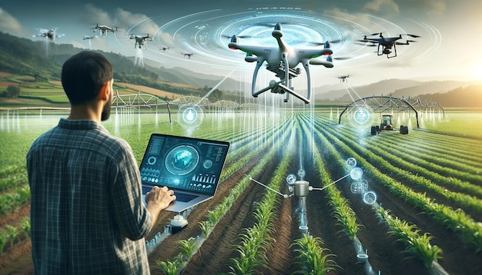

## 2.2 Blockchain and AI: Making Chocolate Fair

## The chocolate industry has received a lot of bad publicity for issues like child labor and deforestation. But blockchain technology is correcting those issues by tracking cacao from the farm to your candy bar with a digital record that cannot be faked. Use a QR code for the chocolate you plan to eat, scan it, and you can see where it was sourced, when it was produced, and whether or not it was ethically produced. Pretty awesome, right? Add in AI technology, that can predict trends, streamline shipping routes, and provide transparency against exploitation. Startups like Sourcemap and NGOs like TrueFootprint offer small holder cocoa farmers in Ghana and Côte d'Ivoire mobile apps that allow them to logging their production work and sell directly to buyers, instead of to unethical greedy middlemen.

## 2.3 Turning Cacao Waste into Gold

## Cacao is going green! Farmers in the cacao supply chain are getting creative. They have stopped discarding pulp, husks and shells. Instead, the farmers are making pulp drinks, turning husks into compost and using cocoa butter in their beauty products. This reduces food waste, builds a sustainable environment and improves the farmers profits! The projects we saw in Ecuador and Indonesia were examples of how the cacao supply chain benefits from this so-called "circular economy" by using all aspects of the cacao supply chain and contributing to a sustainable, profitable income while achieving some of the objectives from the Sustainability Development Goals (SDG 12).

**2.4 Applications and Super Cacao Trees**

Mobile applications like Farmerline and WeFarm put market prices, pest alerts, and farming advice on farmers phones, in their own languages, helping them to outsmart bad deals and grow better crops. Meanwhile, the biotech geniuses at CIRAD and Mars Inc. are developing cacao trees that resist diseases like black pod and can respond to climate change so that we can continue to enjoy the chocolatey flavour.

**2.5 Closing the Technology Gap**

Not all farmers can access these amazing technologies. Some do not have electricity, internet, or the skills to use the technology they might have, and economic situations might not allow them to even consider affordable apps and gadgets. Training, low-cost gadgets, and good internet can help solve this issue. Governments, NGOs, and companies must work in partnership to make this happen, or small farmers will miss out on larger profits and future cacao crops will see a growing gap.

## Chapter 3: Global Cacao Trade and Economic Impacts

**3.1 The Global Cacao Market**

The global cacao market is perceived to be about a $15 billion market with demand coming mostly from chocolate and cocoa-based products (International Cocoa Organization, 2021). Cacao production comes from a few countries, mostly Cote d'Ivoire and Ghana accounting for over 60%, with Indonesia, Nigeria and Ecuador contributing to the majority of the supply. The largest consumers are Europe and North America (Van Merm, 2018). Switzerland and Germany have some of the highest consumption rates of chocolate on a per capita basis in the world. While farmers thrive on growing and selling cacao, they face challenges regarding price volatility, often influenced by weather, pest invasions, geopolitics and consumer demand. While futures markets and cooperatives work together to smooth out prices, farmers are often left with a fraction of the value of the final product (Leissle, 2018).

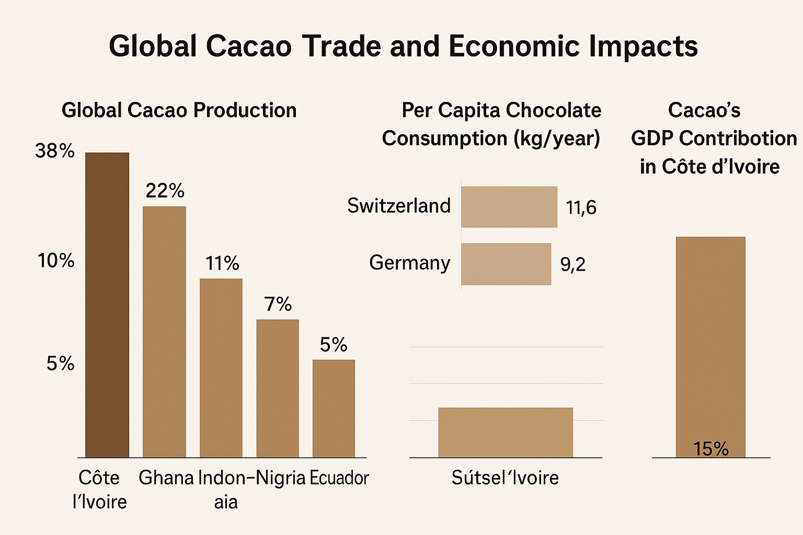

With the continued global rise of sustainability initiatives, shifts in the market are taking place, particularly in cacao where consumers are more likely to want to purchase traceable, ethically sourced or sustainable cacao. Initiated programs like Fairtrade and the Rainforest Alliance, along with corporate programs such as the Cocoa Plan by Nestlé, promote sustainable practices but, presently, account for only 20% of global production. In Latin America, Ecuador and Peru have emerged as popular producers of fine-flavor cacao varieties (including Criollo and Trinitario), that, globally, command premium prices in niche markets. Technological advances are improving efficiencies in some cases (for example, blockchain technology is being used to create greater transparency for cacao supply chains, and drones are used to monitor pest pressures), but the advancements are not widely adopted among smallholder cacao farmers, who make up approximately 90% of cacao production. Climate change remains an existential threat to cacao. In a climate scenario without adaptation, it is estimated that by 2050, 90% of cacao growing regions in West Africa will become unsuitable for cacao production (Läderach et al. 2013). At the same time, an increase in local processing in producing countries, for example Ghana's cocoa processing grinding, is being conducted that retains more of the economic value of the raw materials locally.

**3.2 Economic Benefits and Challenges**

Cacao farming supports the livelihoods for over 2 million farmers in West Africa, No country serves as a more compelling example than Cote d'Ivoire and Ghana who depend heavily on the crop economically. In Cote d'Ivoire, cacao has a per capita income of close to $1 billion, equivalent to 15% of GDP and 40% of export revenue (Afoakwa, 2016). The cacao and chocolate value chain supports rural communities in two ways. First, it creates jobs across the whole value chain in farming, processing and logistics to get the finished good into the consumer's hands. Second, cacao can support rural communities through improvements to infrastructure such as the construction of schools, health centers and the paving of roads. Despite these contributions at the macroeconomic level, many cacao farmers live below1$ USD per day which is below the 2025 international poverty line of $2.15 (World Bank Estimate). The concentration of wealth in rural communities continues to limit the ability of cacao farmers to invest in managed and responsible farming practices and to escape this poverty trap.

Farmers are up against many challenges including fluctuating cocoa prices in international markets, soaring input prices for agricultural products like fertilizers, and exploitation from intermediaries who consume an increasingly larger share of profits. Climate change is having a massive impact on smallholder farmers in particular as rising temperatures and rainfall patterns threaten yields; moreover, reports show that unless there is adaptation, 90% of the areas where cacao is grown in West Africa will be unsuitable for growing cacao by 2050 (Läderach et al., 2013). Child labor is also a significant issue, with an estimated 1.5 million children working on cocoa farms in Côte d'Ivoire and Ghana because of economic desperation (ILO, 2020). Gender inequities shape all of this, as women often constitute large proportions of the cacao agricultural workforce but often lack access to land, credit, and any training who would improve their access to higher income.

## Certifications such as Fairtrade and Rainforest Alliance aim to achieve equitable wages and sustainability, but they only reach about 20% of global cocoa production. The inefficiencies of certifications due to farm level costs, vague or challenging requirements, and declining organizations willing to buy into certification programs and prices have contributed to their challenges (Afoakwa, 2016). In the cocoa value chain, an option is to realize the potential of farmer cooperatives, which enable farmers to collectively bargain and have direct access to markets. Kuapa Kokoo is an example of a farmer cooperative from Ghana that operates in this manner. Another promising option to address the challenges in tackling poverty is a direct trade operations model, which is typically not in their best interest for large corporations with a supply chain of dependencies upon commodities. As a sample, the company Divine Chocolate operates in this manner, whereby they help farmers get a better price (and they invest back into the community), while maximizing profit through direct market access. As always, technological innovations (e.g., mobile app for price transparency, climate-smart approaches such as layering trees) can help but these require investment, and strong implementation to scale this effectively, and ideally get farmers out of poverty by addressing this chain.

## 3.3 Trade Policies and Tariffs

## Trade policies have a considerable impact on the cacao market as tariffs on exports in producing countries and duties on imports in consuming countries affect prices and the incomes of farmers. Government action aimed at increasing intra-African cacao trade efficiency through initiatives such as the African Continental Free Trade Area (AfCFTA) is a main goal of the AfCFTA, so it decreases reliance on European cacao markets. However, exporting cacao in Africa made more difficult by non-tariff barriers such as rigorous EU processes on pesticide residue (Clarence-Smith, 2000).

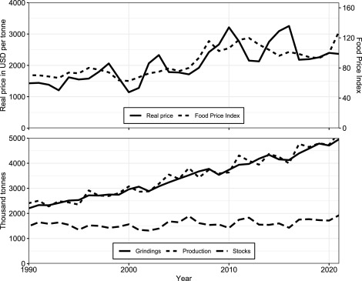

## Chapter 4: Environmental Sustainability in Cacao Production

### 4.1 Deforestation and Land Use

### Cacao farming has played an important role in deforestation, especially in West Africa, where there are an estimated 2 million hectares of land that have been deforested for cacao farms since the year 2000. As another example of monoculture farming, cacao farms do lead to soil degradation and biodiversity loss, as evidenced in the contribution of agroforestry, discouraged development in monoculture (as in respect to agroforestry that best represents, supports and opposes conservation of land-based biodiversity) and cacao land uses. Agroforestry (as used in Mesoamerica) could provide sustainability in land use interventions as an effective means of reducing carbon emissions in the atmosphere and place vegetation for habitat purposes (Bartley, 2005).

### 4.2 Climate Change Impacts

### Climate change will increasingly threaten cacao production by rising temperatures and erratic (unpredictable) rainfall. Cacao prefers restricted climatological conditions (20 to 30 degrees C and with high humidity) that with changes could potentially reduce production areas by 50% by 2050 (CIRAD, 2023). Strategies for introducing drought tolerant varieties of cacao and using enhanced irrigation systems will be better in assisting cacao growers change to climate change.

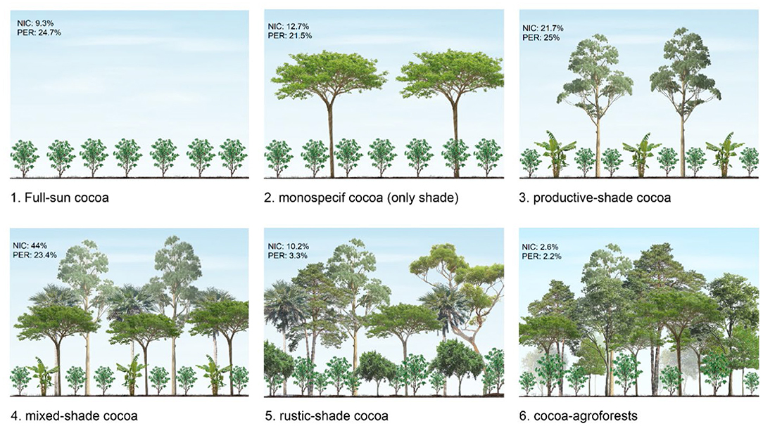

## 4.3 Sustainable Practices

## Sustainable practices, including organic farming and shade-grown cacao, better reduce environmental impact than non-sustainable practices. Legitimate certifications, such as UTZ, can pave the way for eco-friendly growing methods. In order for the market for sustainable practices to grow, more money must be invested in training farmers and in supplying methods or infrastructure for sustainable growing practices. Consumer demand for sustainable chocolate is important for adoption, but price premiums must reach farmers long enough to have an effect (Grivetti & Shapiro, 2009).

# Chapter 5: Social and Ethical Issues in Cacao Supply Chains

## 5.1 Child Labor and Fair Labor Practices

## Child labor is a huge problem in cacao production, with an estimated 1.56 million children working on farms in Côte d'Ivoire and Ghana that produce more than 70% of the world’s cocoa (NORC, 2020). Children as young as five are engaged in hazardous labor on cacao farms, using machetes and carrying large loads, while often skipping school, with poverty keeping them in service. Chocolate farmers earn less than one dollar a day, and today they are receiving only six percent of chocolate’s value at retail, markedly down from 50% in 1970. There is a trafficking aspect also, which has seen 16,000 children from Burkina Faso and Mali trafficked to Ivoirian farms.

## Blockchain and AI is adding to trail of tracing products, including the tool called Sourcemap, as well as furthering ethical sourcing; however, the lack of rigorous enforcement and the lack of infrastructure limits those benefits. Certifications from Fairtrade International and Rainforest Alliance target fair wages, but many farmers resist certification due to the cost or don't adopt either certification due to its annual renewal cost. Only 30-40% of farmers have adopted certification. The Child Labor Cocoa Coordinating Group (CLCCG) and monitoring systems from Nestlé saw reductions in hazardous child labor by 51% in the CLCCG's 26,000 farms, and tried to stress roles in in addressing child labor, yet COVID-19 and the socio-economic impacts increased vulnerabilities. In 2024 there was a super campaign by consumer and advocacy groups, in which the campaign attracted 29,000 signatures, influencing change by introducing some measures. However, the process around standard consumer campaigns, which can target Mars and Mondelēz and includes lawsuits against those same companies for insufficient action. Highest barriers to eradicating child labor revolve around increasing farmer incomes, securing economic participation of children, regardless of their working conditions, responsible school access by governments and economic impacts of crises like pandemics.

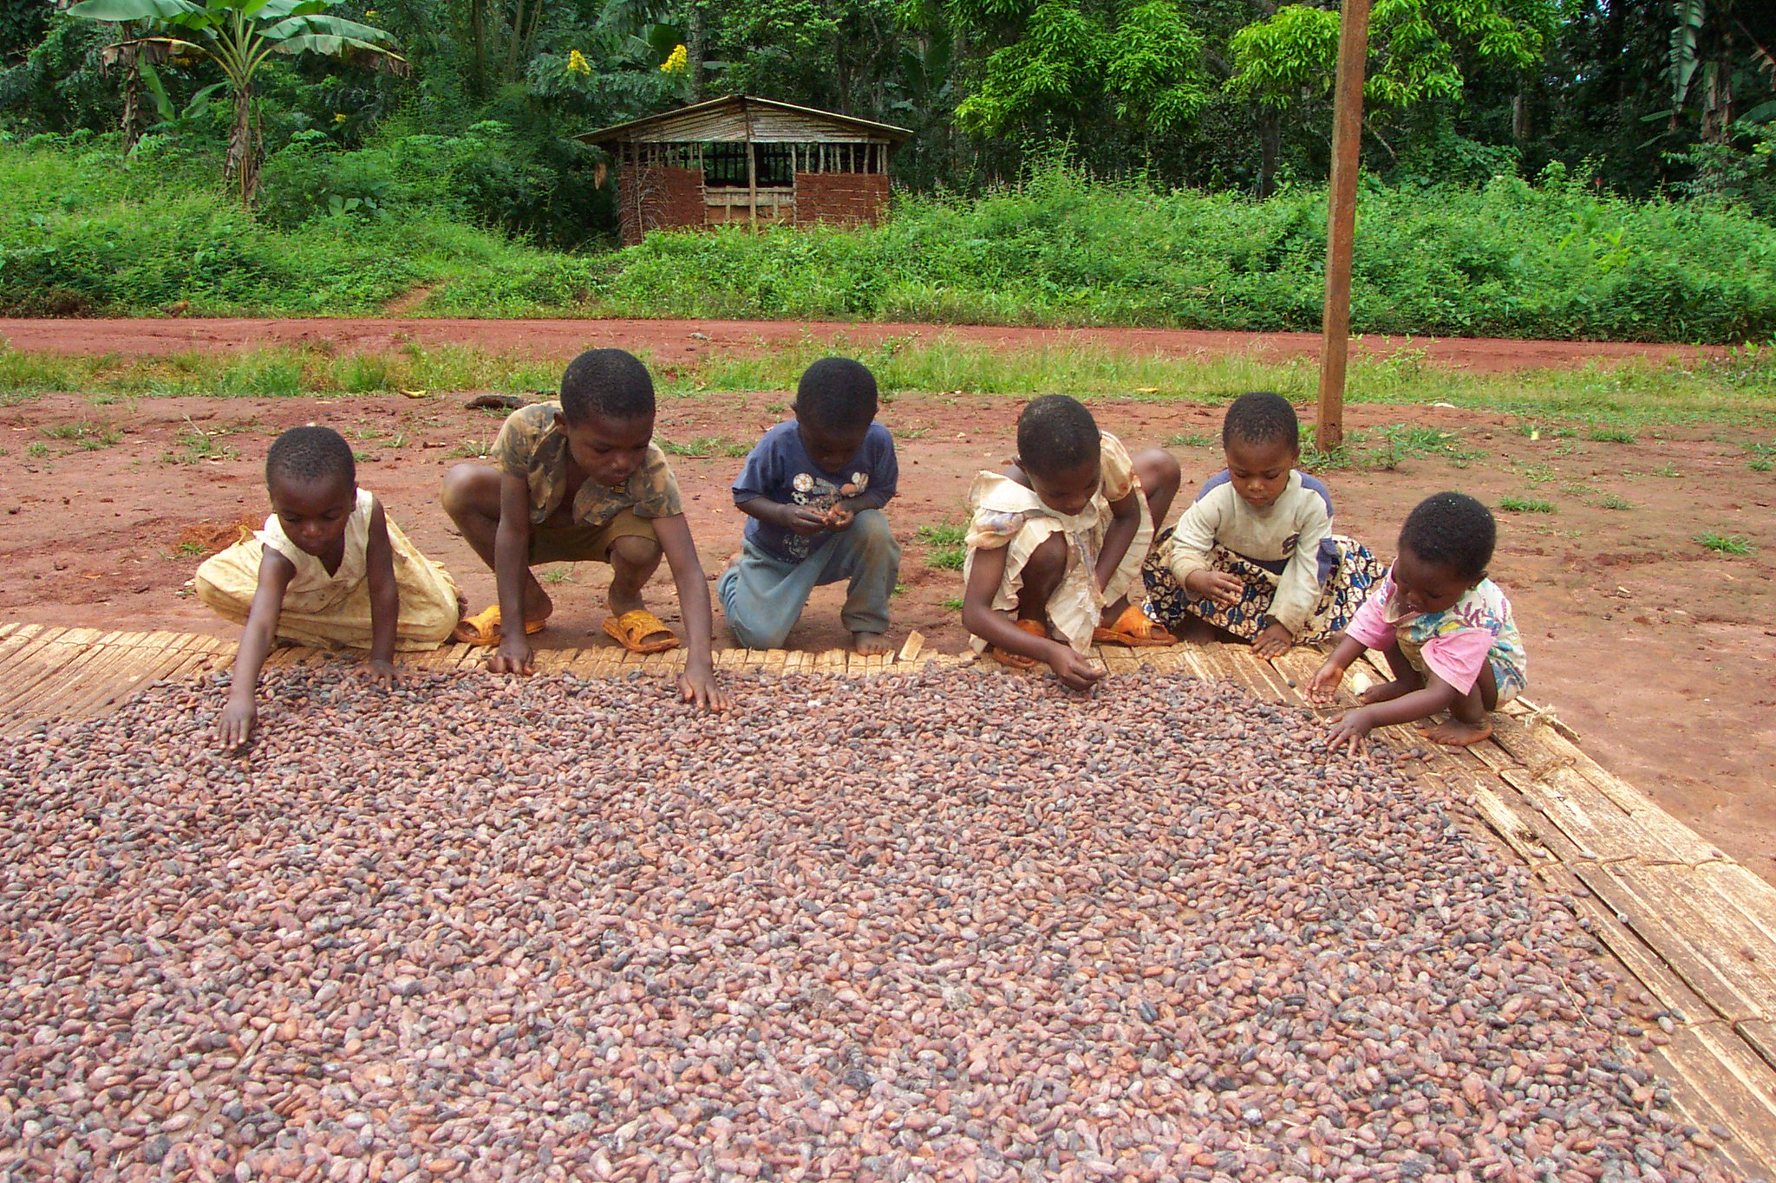

## 5.2 Gender Parity in Cacao Production

## Inspite of struggle to access land, credit and training opportunities, women are essential participants in cacao production. While women in Ghana do similar work as men, they earned 25-30% less than men for comparable work. Mondelēz has a Cocoa Life Programme - which includes access to microfinance and training - which empowers women, increases their income by 15-20% over time, and has reached 60,000 women at the time of writing. Nestlé's Income Accelerator Programme, aimed at reaching 160,000 families by 2030, offers payments paid equally between both husband and wife. Yet women continue to face barriers including culture, and difficult access to technology, to make economic improvements. If the gender gap in cacao production is to be closed, women and women-led cooperatives will need land access and land reform must also take place.

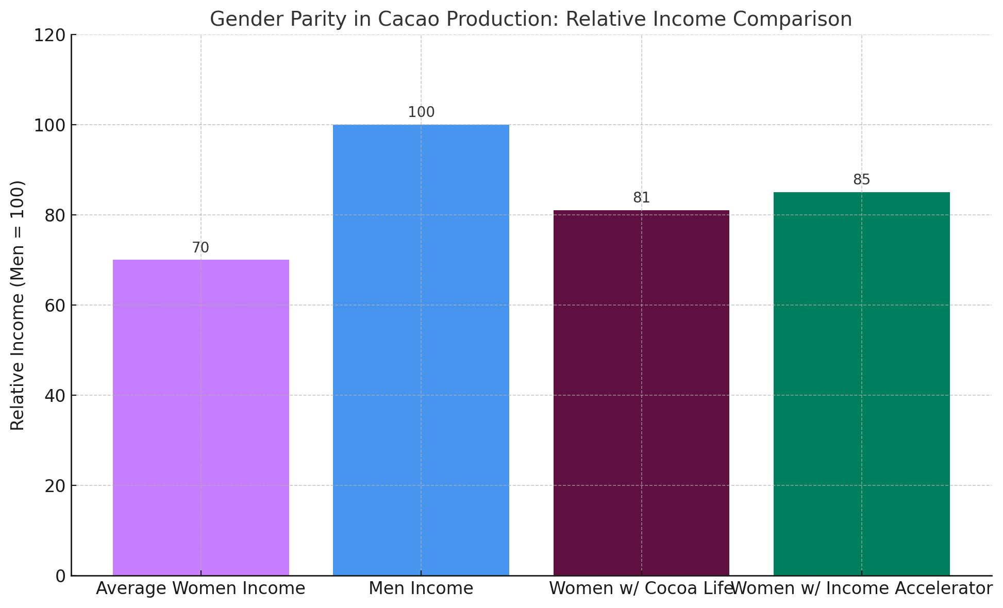

**5.3 Community Development**

Cacao cooperatives build community resilience by creating access to markets, training cooperatives, and offering producers credit. In Colombia, Fedecacao was purposely provided to 50,000 farmers are legally producing cacao beans rather than illegal crops increasing their daily incomes by 10-15% per day. In Côte d'Ivoire, the CACAO project was able to train up to 98% of the cooperatives identified to monitor and check child labor. However, only 30-40% of the farmers participate in cooperatives because the cooperative fees are too high and infrastructure is poor. Ghana launched child protection committees in their communities similar to the one established in Mehame for young women to offer alternatives like sewing apprenticeships that divert them from participating in childMarieaybe Cacaoasfpers. Scaling these community resilience efforts requires major funding into roads, the internet, the governance of cooperatives.

# Chapter 6: Innovations in Cacao Processing and Traceable Products

## 6.1 Developments in Processing Technology for Traceability

## Current processing technologies used for cacao considerably improve quality and traceability, which are equally important for ethical supply chains. Evidence of this is the automated fermentation systems developed by Barry Callebaut, who have embedded both sensors for temperature and pH, to ensure consistency in development of flavors, as well as log the data for traceability (Afoakwa, 2016). Cases such as infrared roasting, in this case conducted by Mars Inc., indicate the fineness of flavor profile is achieved through fine controls of heat, but limit defects to very low levels and provide a tracking mechanism with lots/batches. Furthermore, microbial research currently undertaken by CIRAD explores the role of specific yeast strains to assist with improvement of fermentation, and are being applied to cacao, as well as recording the first log of the beans from the farm of origin. The Rainforest Alliance has also reported on their piloting of a processing system that utilizes blockchain technology in Côte d'Ivoire in which they can track the beans in the entire climate from fermentation to export, that conform to ethical requirements and certifications. All of these advancements represent real opportunities for farmers to comply with the quality and traceability conditions imposed on them in a current ethical market and provide pathways for new market entry.

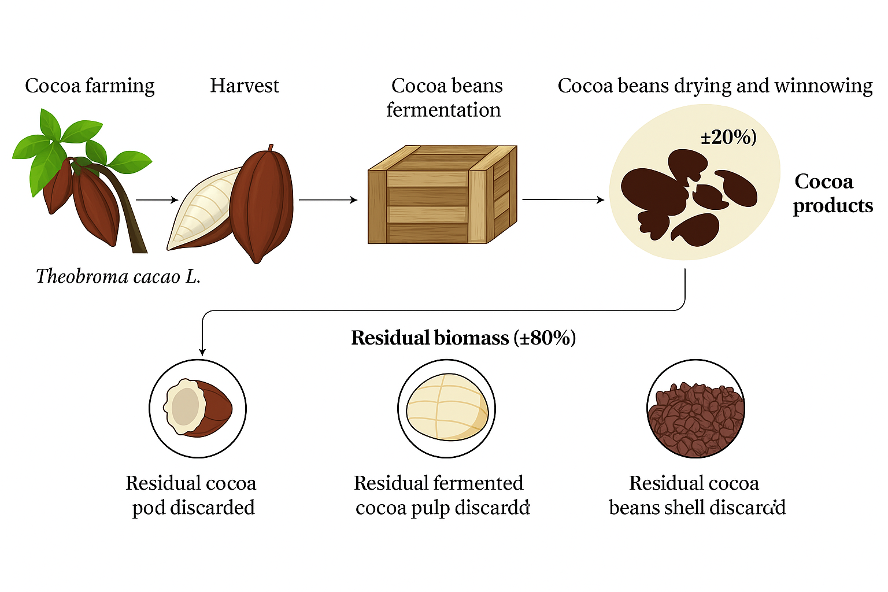

## 6.2 Traceable Cacao Byproducts

## Meanwhile, cacao byproducts are giving farmers additional and diversified income streams with traceability at the forefront. For example, cocoa butter can be used in cosmetics, such as L'Oréal products, which use blockchain technology to trace the cocoa butter back to the farmer in order to ensure they are following this sustainable sourcing method. The pulp from cacao might be turned into juices and alcoholic beverages and there are new companies such as Cocoa Pulp Co. that are using QR codes to trace their product back to the individual farms in Ecuador (Forward Fooding, 2024)! The Rainforest Alliance certifies these byproducts to demonstrate that there is no child labor or deforestation, with digital platforms tracking the every step of the supply chain. These innovations are allowing for reduced waste with traceable incomes to farmers and a more economic resilience.

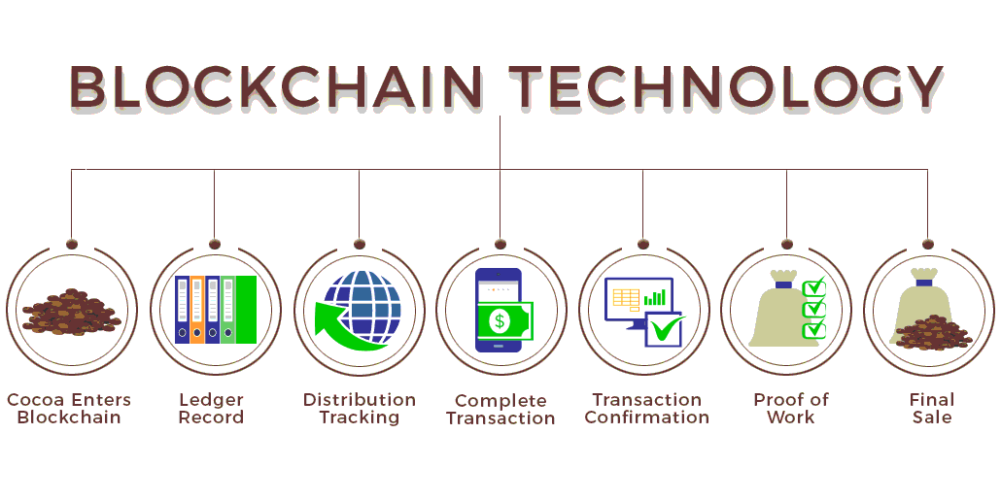

**6.3 Artisanal chocolate and traceable supply chains**

The emergence of artisanal, bean-to-bar chocolate brands, which emphasize traceability, engages consumer trust. One example is Tony's Chocolonely, which has used a blockchain platform, Sourcemap, to trace cocoa to specific farms in Ghana, including varieties and terroir (Leissle, 2018). To assist those brands, the Rainforest Alliance offers a certification program to verify ethical practices with farmers now having mobile apps to upload production data. Using these apps, artisanal chocolatiers are able to follow a direct trade model, while better engaging with smallholders to either provide them with compensation or how to pay them while also providing the consumers transparency of the supply chain. This should help educate consumers about supply chains, while support traceable and sustainable production.

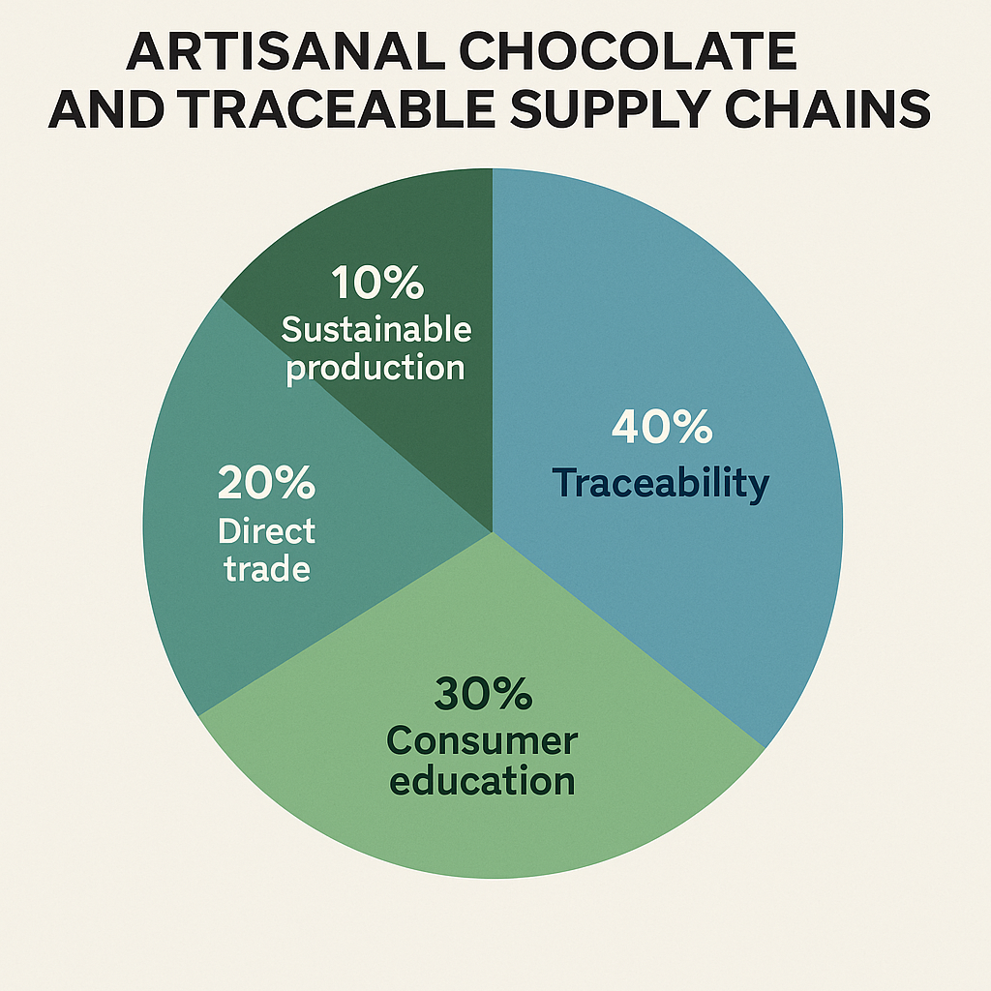

# Chapter 7: Consumer Trends and Technology-Driven Market Dynamics

## 7.1 Demand for Ethical Traceable Chocolate

## Driven by consumer demand for ethical and sustainable chocolate, manufacturers are adopting credible traceability technologies. Blockchain solutions enable stakeholders to track cocoa from the farm to the end consumer. For example, Nestlé and the Rainforest Alliance have developed and implemented a blockchain traceability technique that allows consumers to access ethical compliance information via QR codes on the product's packaging. In 2024, over 60% of European consumers made some preference for certified products, and in Germany and Switzerland, the same certified products sold 15% more after the sale of a product with the Rainforest Alliance certification label and also the Fairtrade certification label. In addition, products like single-origin chocolates (from regions like Ecuador’s Manabí province,) are purposely advertised to specifically discerning consumers, while companies utilize AI analytics to seek demand trends (forecasting) so they are able to optimize supply chain activities. Distinct technologies have been undertaking new phases of transparency from member units to consumer where they are attempting to provide worldwide and sustainable remedies to problems like child labor and deforestation.

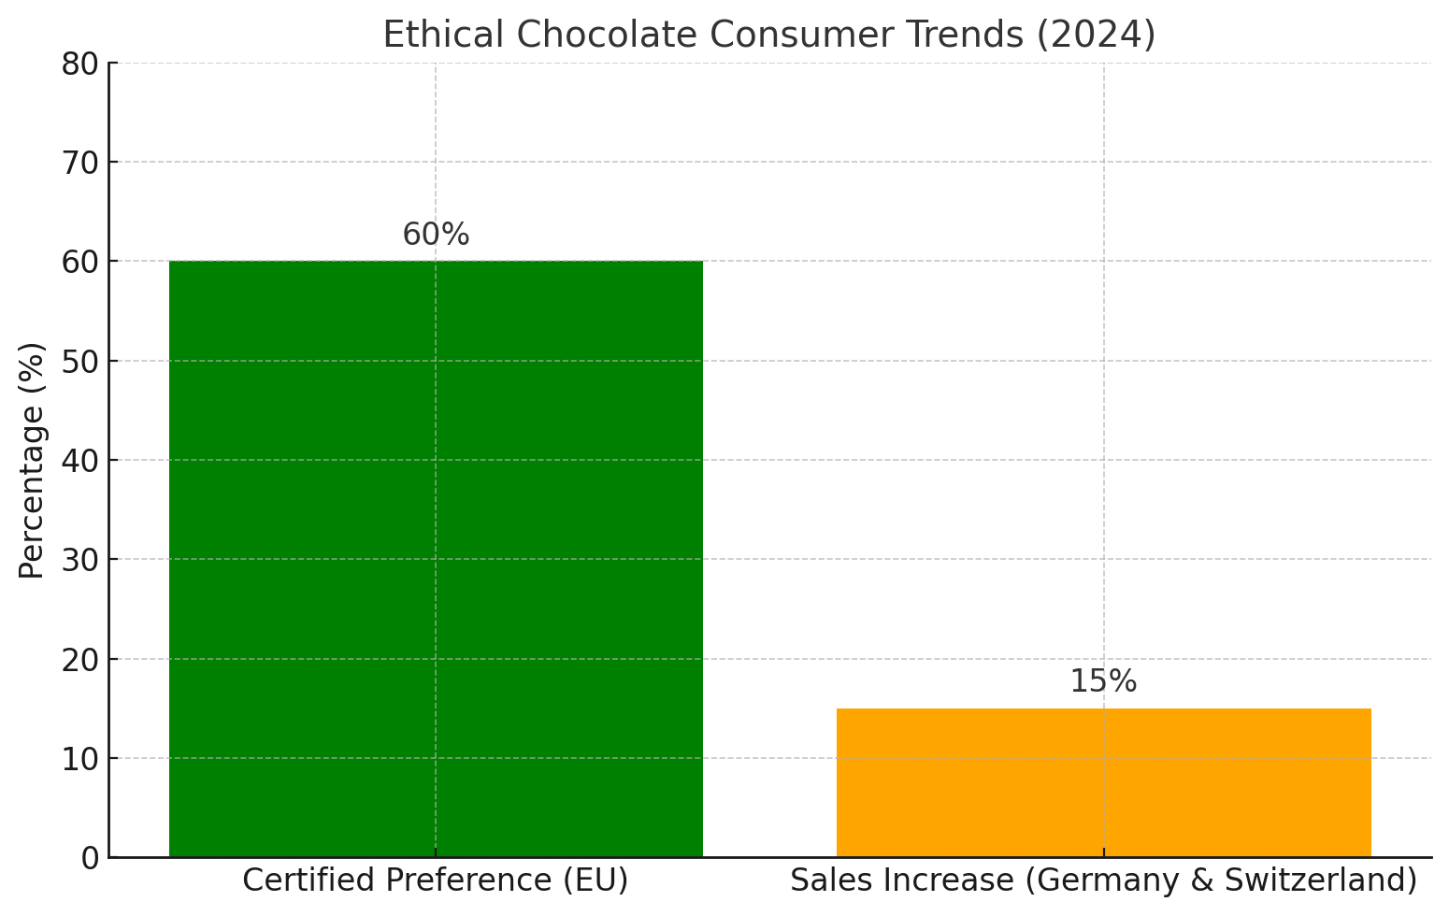

## 7.2 Healthy Products with Traceable ingredients

## Most authorities cite growing demand for low-sugar/high-cocoa content chocolate and functional products that contain superfoods such as quinoa or chia seeds. There have been discussions about sending cacao’s flavonoids and their relationship to heart health (Dillinger et al., 2000) undoubtedly enhances the potential.

## Traceability as a commitment to health and ethical standards ensures products meet criteria, and with blockchain systems it can track organic certification from farm to shelf. Similarly, digital platforms created by organizations like Rainforest Alliance are able to communicate the lack of pesticide residues in sold products, while apps used by the farmer and priced for their benefit like WeFarm, will also provide information about organic practices. In 2023, sales of health-focused chocolates in North America grew at 12% with purchasing based on transparency and traceable supply chains.

**7.3 E-Commerce and Traceable Direct-to-Consumer Sales**

E-commerce platforms provide smallholder farmers (and artisanal brands) the ability to access a global market using traceable products. Mobile application systems like Farmerline have provided farmers in Ghana with market prices and pest alerts, giving them the ability to sell directly to consumers with e-commerce platforms like CocoaTrade (Kamilaris et al., 2019). Blockchain technology supports these traceability platforms, whereby consumers can seamlessly visualize farm data through QR codes which helps create a trustworthy brand. The Rainforest Alliance has developed e-commerce systems to support the traceability of cocoa by certifying cocoa and increasing the selling prices of traceable cocoa for farmers from 10 – 20% in value with direct trade. As of 2024, direct-to-consumer sales had grown in value by 18% worldwide, which is amplified by increasingly transparent technology-enabled sales.

# Chapter 8: The Future of the Cacao Industry with Traceability

## 8.1 Biotechnology for Traceable, Resilient Cacao

## Biotechnology, such as CRISPR edited cacao trees, is helping cacao trees survive diseases like black pod and climate-related stresses to provide sustainable and traceable sourcing. CIRAD and Mars Inc. are exploring the development of cacao varieties with trackable genetic profiles so farmers will provide certified disease-free cocoa for export using blockchain (CIRAD 2023). Precision agriculture technologies such as drones and soil sensors in Côte d'Ivoire that monitor tree health also keep records for traceability and are expected to reduce loss of cocoa at the farm gate by 15%. The Rainforest Alliance is using these technologies as an integral part of a certification program that commits agricultural producers to the standards in protecting the environment. This solves the future of the supply chain regarding the compliance of sustainable practice and environmental stewardship with consumer needs for transparency.

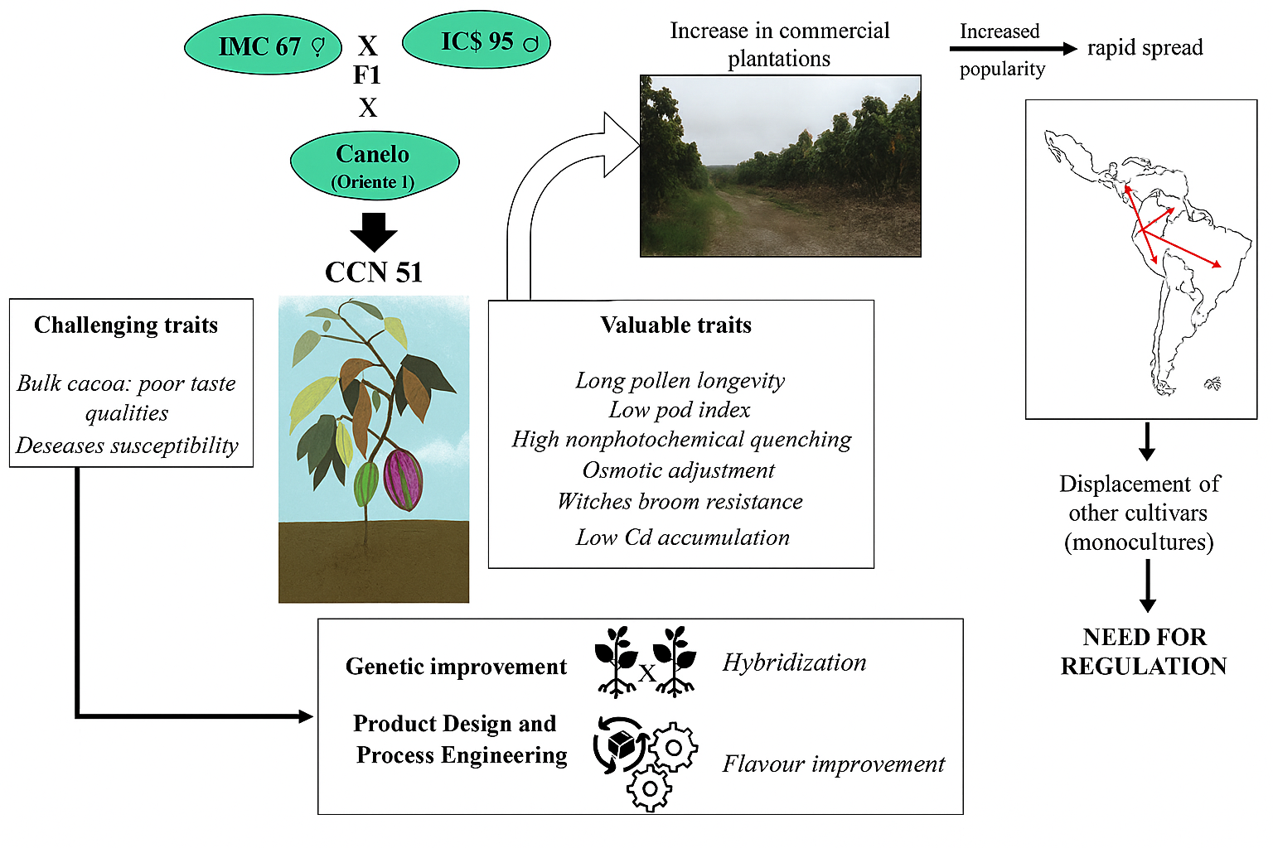

## 8.2 Policy and Global Collaboration to Support Traceability

## International policy frameworks that promote traceability are important to a resilient cacao industry. To this end, the International Cocoa Organization (ICCO) sponsors cooperative efforts to create an agri-food blockchain to standardize the use of traceable blocks, and Côte d'Ivoire and Ghana are piloting its traceable export systems in 2024. The Rainforest Alliance partners with governments to help them enforce their anti-deforestation laws and uses a satellite monitoring system that can verify whether farms across cocoa-growing nations comply with their country's regulations. The African Continental Free Trade Area (AfCFTA) seeks to contribute to intra-African trade by prioritizing traceable cocoa, reducing dependency on European markets; however, the system of trade still works with non-tariff barriers, e.g., EU regulating the levels of pesticide that smallholder farmers can use, and they have to maintain policy harmonization to ensure that smallholders have equitable access.

## 8.3 Technology empowers farmers

## By connecting smallholder farmers through technology, we will eventually have traceable, sustainable cocoa. Mobile applications like WeFarm and Farmerline for instance connect 70, 000 farmers in Ghana with market data and training, while allowing farmers to upload.production information to blockchain platforms (Anane et al., 2022). The Rainforest Alliance’s training program allows farmers to be trained to use drones and sensors, with 40% experiencing this training in Côte d'Ivoire by 2023. Public-private partnerships, including those being developed with food and beverage companies like Nestlé have contributed to the supply of low-cost devices; although only 30% of farmers can access the internet required to use this technology. If we want traceable and sustainable cocoa, we need to scale this technology up. This will require investment in the rural infrastructure of these technologies to improve accessibility of benefits from practical, traceable production.

## Critical Analysis

Blockchain and certifications like Rainforest Alliance offer promising advances in traceability, but their impact will be limited by the high costs and uneven access. Fourty percent (40%) of farmers use digital tools, and companies' pledges to social responsibility and climate sustainability will inevitably overlook social sustainability within their supply chain as they quickly shift back to manufacturing without fully committing to making systemic change. Traceability can expose social issues like child labor, but does not get to the root causes of those issues, such as poverty - the majority of farmers only earn fourty percent (40%) of a living income level. To improve social sustainability, simply bringing technology into play will not be enough; fair trade policy design, infrastructure investment, and farmer empowerment within the supply chain should be emphasized, rather than farmer exploitation for corporate intent, in general.

**Chapter 9: Conclusion**

Cacao has been honored as a sacred crop, currency, and medicine in Mesoamerica for 3,000 years (Chapter 1). The $15 billion global marketplace is dominated by Côte d'Ivoire and Ghana (60% of supply) and is mostly consumed in Europe and North America (Chapter 3.1). Farmers live under less than $1/day on, on average, 5-7% of the retail price for the chocolate (Chapter 3.2). In Côte d'Ivoire, cacao accounts for 15% of GDP and 40% of exports, and chocolate producers indicate that climate change will result in 90% of West African cacao growing areas becoming unsuitable by 2050 (Chapter 4.2). Consumer goods are increasingly encouraging deforestation (Côte d'Ivoire has lost 2 million hectares of forested land since 2000) and a shocking 1.56 million children in Côte d'Ivoire and Ghana are the victims of child labor (Chapters 4.1, 5.1). Women account for an estimated 40% of all participation in cacao production, earn 25-30% less than men (Chapter 5.2), yet play a critical role in maintaining cacao as a viable crop.

Only 20% of all cocoa is covered by certifications like Fairtrade due to prohibitive costs (Chapter 3.2). Nevertheless, several new technologies have emerged to facilitate farm management, traceability, and ethical sourcing, including drone technologies, blockchain technologies, and artificial intelligence (AI) (Chapters 2, 6; Chapter 7.3), as well as e-commerce and apps to support their productivity in which farmers' incomes have increased by 10-20% and prospects that moving into future use predictions (Chapter 7.3). In 2024, 60% of European consumers indicated a preference for the guarantee of certified products in sustainable chocolate (Chapter 7.1). Further development of biotechnologies and policies such as starting with the African Continental Free Trade Agreement (AfCFTA), promotes resilience, traceability, and benefits of sustainability, irrespective of EU regulations that threaten the well-being and advancement of smallholders (Chapter 8). Importantly, only approximately 40% of all cocoa farmers have access to the new digital tools. In addition to widespread poverty, the constant march of unfair trade, infrastructural development, and empowerment to improve the sustainability and equity of cacao can create a sustainable and ethical cacao industry.

### References

1. Anane, J. K., Debrah, Y. A., & Owusu, G. (2022). Exploring the potential of blockchain technology to ensure fair labor practices in the Ghana cocoa supply chain. Journal of African Business, 23(2), 397–418. <https://doi.org/10.1080/15228916.2021.1896712>
2. Afoakwa, E. O. (2016). Cocoa production and processing technology. CRC Press
3. Bai, C., Quayson, M., & Sarkis, J. (2022). Analysis of blockchain’s enablers for improving sustainable supply chain transparency in Africa’s cocoa industry. Journal of Cleaner Production, 358, 131896. <https://doi.org/10.1016/j.jclepro.2022.131896>
4. Bartley, B. G. D. (2005). The genetic diversity of cacao and its utilization. CABI Publishing.
5. Berdou, E., & Casas, I. (2020, June 17). Blockchain technology tested in Côte d’Ivoire cocoa sector offers sustainable solution. Confectionery News. <https://www.confectionerynews.com/Article/2020/06/17/Blockchain-technology-tested-in-Cote-d-Ivoire-cocoa-sector-offers-sustainable-solution>
6. CIRAD. (2023). Biotechnological advances in cacao: Developing disease-resistant varieties. <https://www.cirad.fr/en/our-research/research-results/2023/cacao-disease-resistance>
7. Chandan, A., John, M., & Potdar, V. (2023). Achieving UN SDGs in food supply chain using blockchain technology. Sustainability, 15(3), 2109. <https://doi.org/10.3390/su15032109>
8. Clarence-Smith, W. G. (2000). Cocoa and chocolate, 1765–1914. Routledge.
9. Coe, S. D., & Coe, M. D. (2013). The true history of chocolate (3rd ed.). Thames & Hudson.
10. Dillinger, T. L., Barriga, P., Escárcega, S., Jimenez, M., Lowe, D. S., & Grivetti, L. E. (2000). Food of the gods: Cure for humanity? A cultural history of the medicinal and ritual use of chocolate. The Journal of Nutrition, 130(8S), 2057S–2072S. <https://doi.org/10.1093/jn/130.8.2057S>
11. Forward Fooding. (2024, August 7). Beyond the wrapper: The cacao supply chain. <https://forwardfooding.com/blog/beyond-the-wrapper-the-cacao-supply-chain/>
12. Grivetti, L. E., & Shapiro, H. Y. (Eds.). (2009). Chocolate: History, culture, and heritage. Wiley.
13. Hecht, H. (2017). Chocolate supply ready for blockchain disruption. Industry Report. <https://cryptotvplus.com/blockchain/>
14. International Cocoa Organization. (2021). Global cocoa production statistics. <https://www.icco.org/statistics/>
15. International Labour Organization. (2020). Child labour in cocoa production in Côte d’Ivoire and Ghana. <https://www.ilo.org/global/topics/child-labour/lang--en/index.htm>
16. Mars Incorporated. (2022). Cocoa for generations: Sustainable farming and biotechnology. <https://www.mars.com/sustainability/cocoa-for-generations>
17. Kamilaris, A., Fonts, A., & Prenafeta-Boldú, F. X. (2019). The rise of blockchain technology in agriculture and food supply chains. Trends in Food Science & Technology, 91, 640–652. <https://doi.org/10.1016/j.tifs.2019.07.034>
18. McNeil, C. L. (Ed.). (2006). Chocolate in Mesoamerica: A cultural history of cacao. University Press of Florida.
19. Leissle, K. (2018). Cocoa. Polity Press.
20. Nitidae. (2020). Blockchain: An opportunity to improve the traceability of sustainable cocoa in Côte d’Ivoire. CTA. <https://www.cta.int/en/article/blockchain-an-opportunity-to-improve-the-traceability-of-sustainable-cocoa-in-cote-d-ivoire-sid08d8b8c8c-4e8e-4e3f-9e0e-6f6b3b3b3b3b>
21. Anane, J. K., Debrah, Y. A., & Owusu, G. (2022). Exploring the potential of blockchain technology to ensure fair labor practices in the Ghana cocoa supply chain. *Journal of African Business*, 23(2), 397–418. [Link](https://doi.org/10.1080/15228916.2021.1896712)
22. Afoakwa, E. O. (2016). *Cocoa production and processing technology*. CRC Press.
23. Bai, C., Quayson, M., & Sarkis, J. (2022). Analysis of blockchain’s enablers for improving sustainable supply chain transparency in Africa’s cocoa industry. *Journal of Cleaner Production*, 358, 131896. [Link](https://doi.org/10.1016/j.jclepro.2022.131896)
24. Bartley, B. G. D. (2005). *The genetic diversity of cacao and its utilization*. CABI Publishing.
25. Berdou, E., & Casas, I. (2020, June 17). Blockchain technology tested in Côte d’Ivoire cocoa sector offers sustainable solution. *Confectionery News*. [Link](https://www.confectionerynews.com/Article/2020/06/17/Blockchain-technology-tested-in-Cote-d-Ivoire-cocoa-sector-offers-sustainable-solution)
26. CIRAD. (2023). Biotechnological advances in cacao: Developing disease-resistant varieties. [Link](https://www.cirad.fr/en/our-research/research-results/2023/cacao-disease-resistance)
27. Chandan, A., John, M., & Potdar, V. (2023). Achieving UN SDGs in food supply chain using blockchain technology. *Sustainability*, 15(3), 2109. [Link](https://doi.org/10.3390/su15032109)
28. Clarence-Smith, W. G. (2000). *Cocoa and chocolate, 1765–1914*. Routledge.
29. Coe, S. D., & Coe, M. D. (2013). *The true history of chocolate* (3rd ed.). Thames & Hudson.
30. Dillinger, T. L., Barriga, P., Escárcega, S., Jimenez, M., Lowe, D. S., & Grivetti, L. E. (2000). Food of the gods: Cure for humanity? A cultural history of the medicinal and ritual use of chocolate. *The Journal of Nutrition*, 130(8S), 2057S–2072S. [Link](https://doi.org/10.1093/jn/130.8.2057S)
31. Forward Fooding. (2024, August 7). Beyond the wrapper: The cacao supply chain. [Link](https://forwardfooding.com/blog/beyond-the-wrapper-the-cacao-supply-chain/)
32. Grivetti, L. E., & Shapiro, H. Y. (Eds.). (2009). *Chocolate: History, culture, and heritage*. Wiley.
33. Hecht, H. (2017). Chocolate supply ready for blockchain disruption. *Industry Report*. [Link](https://cryptotvplus.com/blockchain/)
34. International Cocoa Organization. (2021). Global cocoa production statistics. [Link](https://www.icco.org/statistics/)
35. International Labour Organization. (2020). Child labour in cocoa production in Côte d’Ivoire and Ghana. [Link](https://www.ilo.org/global/topics/child-labour/lang--en/index.htm)
36. Mars Incorporated. (2022). Cocoa for generations: Sustainable farming and biotechnology. [Link](https://www.mars.com/sustainability/cocoa-for-generations)
37. Kamilaris, A., Fonts, A., & Prenafeta-Boldú, F. X. (2019). The rise of blockchain technology in agriculture and food supply chains. *Trends in Food Science & Technology*, 91, 640–652. [Link](https://doi.org/10.1016/j.tifs.2019.07.034)
38. McNeil, C. L. (Ed.). (2006). *Chocolate in Mesoamerica: A cultural history of cacao*. University Press of Florida.
39. Leissle, K. (2018). *Cocoa*. Polity Press.
40. Nitidae. (2020). Blockchain: An opportunity to improve the traceability of sustainable cocoa in Côte d’Ivoire. CTA. [Link](https://www.cta.int/en/article/blockchain-an-opportunity-to-improve-the-traceability-of-sustainable-cocoa-in-cote-d-ivoire-sid08d8b8c8c-4e8e-4e3f-9e0e-6f6b3b3b3b3b)
41. Van Merm, J. (2018). The global chocolate market: Trends and challenges. *Chocolate Industry Review*.
42. Amegashie-Duvon, T. (2014). Blockchain adoption in Ghanaian cocoa: equity in focus. *Journal of African Technology*.
43. Musah, A., et al. (2020). Blockchain for fraud reduction in Ghana’s cocoa supply chain. *Journal of Agricultural Transparency*.
44. Quayson, M. (2021). Blockchain empowerment: Income transparency for Ghanaian farmers. *African Tech Review*.
45. Kraft, L., & Kellner, D. (2022). Digital accountability: Blockchain and fair compensation in West Africa’s cocoa production. *Journal of Development Studies*.
46. Mathew, S. (2020). Ethical sourcing with blockchain in Ghana’s cocoa networks. *Sustainability in Practice*.
47. Salih, B., & Mhlanga, S. (2023). Blockchain’s role in social responsibility within cocoa supply chains. *Journal of Social Tech*.
48. Berdou, E., & Casas, I. (2020). Blockchain technology tested in Côte d’Ivoire cocoa sector. *Confectionery News*.
49. Chandan, A., John, M., & Potdar, V. (2023). Achieving UN SDGs in food supply chain using blockchain technology. *Sustainability*.
50. International Cocoa Initiative. (2024). *International Cocoa Initiative*. Wikipedia. [Link](https://en.wikipedia.org/wiki/International_Cocoa_Initiative)